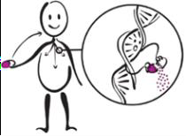Your ABCG2 Genetic Test Results and What They Mean

ABCG2: Decreased Function

Pharmacogenomic Testing Overview
Pharmacogenomic (PGx) testing looks at how your genes affect your response to certain medications. Genes are pieces of DNA that provide instructions to make our bodies look and work as they do. Some genes affect the way medications work in the body. When comparing a group of people, there can be slight differences in the structure of each person’s genes. These differences can affect how people respond to medications.

Some gene differences might make it harder for the body to get rid of some medications. This means that the usual dose of the medication may cause unexpected side effects. Some gene differences can cause the body to use up a medication too fast. This means that normal doses will not work as well, and the person may need higher doses. Some gene differences will not let certain medications work in the body at all. This means a different medication may work better. Some gene differences increase your chances of side effects to medications. This means that you may need to avoid certain medications.

This gene test may have been part of a panel of genes or a single gene test. The results and affected medications described below may not be relevant to your current care, but could be in the future.

About the ABCG2 Gene
The test we did was for a gene called the transporter adenosine triphosphate (ATP) – binding cassette G2 (abbreviated ABCG2). This gene makes a transporter that helps move medications from inside our cells to outside, so that our bodies can eventually excrete or get rid of the medication. Depending on how well this transporter functions can impact how medications are dosed. It is common to have slight variations in the ABCG2 gene that affect how the transporter works. Depending on these variations, people are considered to have Poor (PF), Decreased (DF), or Normal Function (NF).



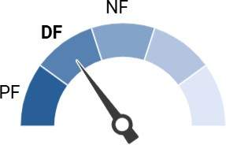
Your ABCG2 result puts you in the decreased function group. People who have decreased function for ABCG2 may need lower than normal doses of medications that interact with this transporter. About 18% of our patients have decreased function for ABCG2. Your healthcare providers can use your test result to help decide what medications and what dose may be the best for you.

The following medication interacts with the ABCG2 transporter:

Rosuvastatin (used to treat high cholesterol)

Do not make any adjustments to your medications without first speaking to your healthcare provider.

Because your genes stay the same even as you age, it is important for you to share this result with your other doctors and pharmacists outside Children’s Mercy. This result may affect how doctors prescribe medications throughout your life.

More Information
- Research continues to be done on what medications are affected by genetic test results. For more details about the ABCG2 gene, please go to www.clinpgx.org.
- If you have questions about your pharmacogenetic test results or specific treatment options, discuss them with your healthcare provider or call 816-601-3360 to schedule an appointment at the Children’s Mercy GOLDILOKs Clinic.
- If interested in volunteering for pharmacogenetic research, please contact the Children’s Mercy Research Institute at pharmacogeneticsresearch@cmh.edu.

Revised October 2025

